Robohelp
[A Guide for Beginner]
Created By: Pradip
Email: enter your email id

Table of Contents
Robohelp 1
1 About Skin: 4
2 Creating skin file 5
3 How to use the Skin: 5
4 Open an Existing Project: 11
5 Configuration: 12
6 Microsoft FrontPage: 13
7 Common Properties 14
7.1.1 To change the color of Content, Index, Search 16
7.1.2 To change the color of the Next, Previous, Print, Atoc Tab 17
8 Custom Build: 18
9 HTML Page Templates: 19
9.1 Background colors: 20
10 Publishing Options: 20
11 Webhelp: 22
12 The Layout Section 22
12.1 To get Company Logo and header background color: 24
13 The Navigation Section: 25
14 The Table of Contents, Keyword Index and Full Text Search Section: 26
15 Project Files 29
15.1 Baggage Files: 29
15.1.1 Importing Baggage files from other projects 30
15.1.2 Removing Baggage files 31
15.1.3 Renaming Baggage files 31
16 Why to Use Help and Manual? 32
17 Final Output of the PROJECT SKIN 33

Table of Figures
Figure 1: Help and Manual Icon 4
Figure 2: Publish Help Project 6
Figure 3: New Project 7
Figure 4: New Help Project 7
Figure 5: Output File 8
Figure 6: Help Manual 8
Figure 7: Create New Help Project 9
Figure 8: Publish Help Project 10
Figure 9: Creating Webhelp (HTML) 10
Figure 10: Configuration Properties 12
Figure 11: FrontPage 13
Figure 12: Text Variables 15
Figure 13: Custom Build 18
Figure 14: HTML Page Templates 19
Figure 15: Publish Options 21
Figure 16: Publish Help Project 21
Figure 17: Layout Section 23
Figure 18: Navigation Section 25
Figure 19: Table of Contents 26
Figure 20: Keyword Index 27
Figure 21: Full Text Search 28
Figure 22: Baggage Files 30
Figure 23: Importing Baggage File 31
Figure 24: Project Output 33

Introduction:
RoboHelp is a help authoring tool (HAT) created by eHelp Publication. RoboHelp is application for developing online help; Web based help, such as JavaHelp and RoboHelp's WebHelp.
RoboHelp HTML
RoboHelp Office consists of the standard RoboHelp--used for developing WinHelp--and RoboHelp HTML, which allows you to develop HTML Help, JavaHelp and WebHelp.
HTML Help is the format Microsoft is now using in their Office 2000 products. It consists of a compressed file that explodes into a series of HTML help files.
WebHelp is a form of HTML Help provided in RoboHelp HTML, without the compressed file, thus making it suitable for use on the Internet. WebHelp can be delivered as DHTML or Java-based.
JavaHelp is a format that is used in few applications and is completely based on Java.

About Skin:
- Select a skin file and the appearance and layout of the entire program is transformed in seconds
- Help & Manual enables you to do this with your HTML-based output.
- You can save your entire design in an .hmskin file and then select this file when you publish to apply the layout to the current project without changing any of the project's own settings.

Figure 1: Help and Manual Icon

Creating skin file
Skin files contain everything you need to style your HTML-based output: Text and table styles, user-defined variables, your Baggage files (template graphics and logos), HTML page templates and all the settings and templates for Webhelp. You can turn any project into a skin file just by saving it as a skin and you can edit skin files in Help & Manual, just like normal projects
- Open a project with a design that you want to use for other projects.
- Select Save As... In the Application Menu and choose the Skin XML File option.
- Choose a place to save the skin, enter a name and save.
- You will be asked which configuration components of your project you want to include in your skin. You should normally include all the listed components.
- You can now compile other projects to HTML-based output formats with your new skin.
Note:
Whatever the changes you made it should be done on the Skin

How to use the Skin:
- Open a project of your own, select Publish in the Project tab, then select Web help or HTML Help as the output format.
- In the Publish Dialog click on the Browse button in the Compile with skin: field and select one of the standard .hmskin files in the Skins folder in the Help & Manual program directory.
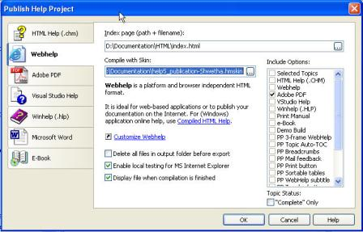
Figure 2: Publish Help Project

Create a New Project:
- Use help5_publication.hmskin. Go to Help and Manual Icon
- Select New.
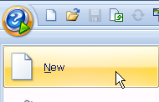
Figure 3: New Project
- Create New Project
- Select Create a New help project,
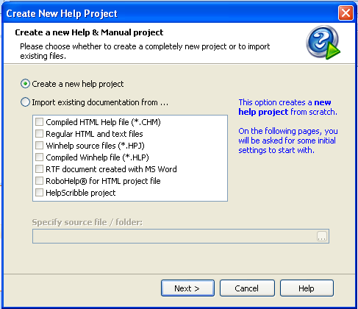
Figure 4: New Help Project
- Click Next
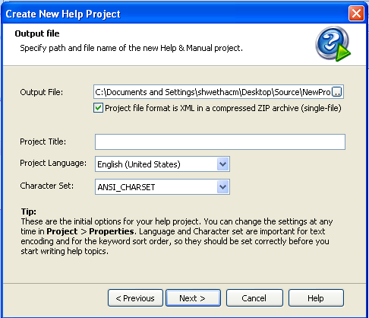
Figure 5: Output File
- On the Project Title type the name (Project Name) the below screen displays
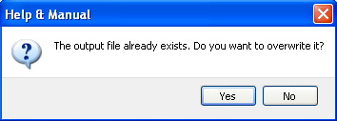
Figure 6: Help Manual
- Click Yes
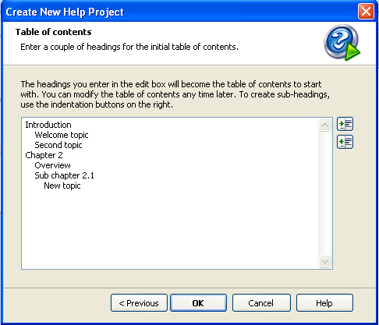
Figure 7: Create New Help Project
- Click OK
- The New Project screen on the left side displays as below
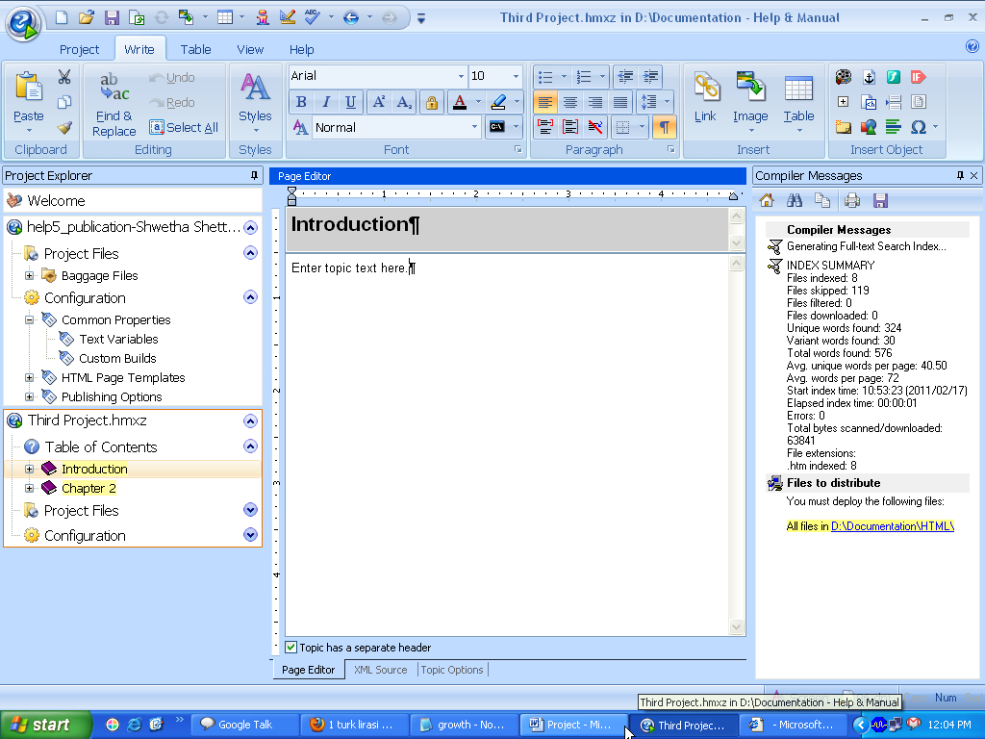
- New project with three levels of sample
- Create three levels of sample topics in H&M one inside the other
- Create a new skin with shades of blue when you generate the webhelp, use this skin
- Generate a Webhelp, output for this project which shows the generic online help layout
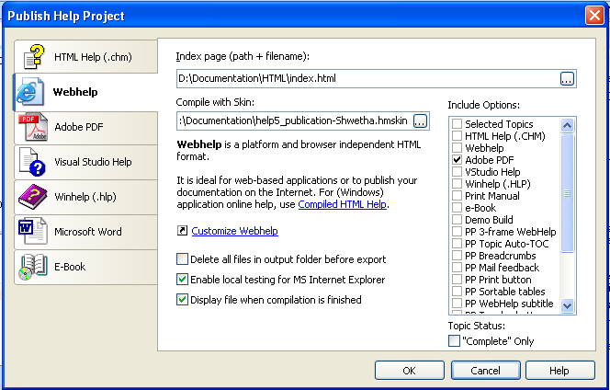
Figure 8: Publish Help Project
- Click on OK, the below screen shot displays
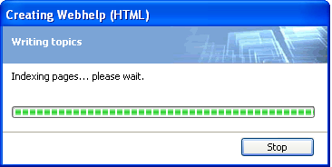
Figure 9: Creating Webhelp (HTML)
- Webhelp skins have a .hmskin file extension these can be opened in the tool itself
- The project contains lots of topics which is online help for the help and manual tool
- Use Company colors and fit Company logo
- Use the shades of blue

Open an Existing Project:
- Click on the H&M icon select Open
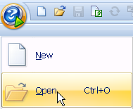
- Open an Existing Project The below screen displayed
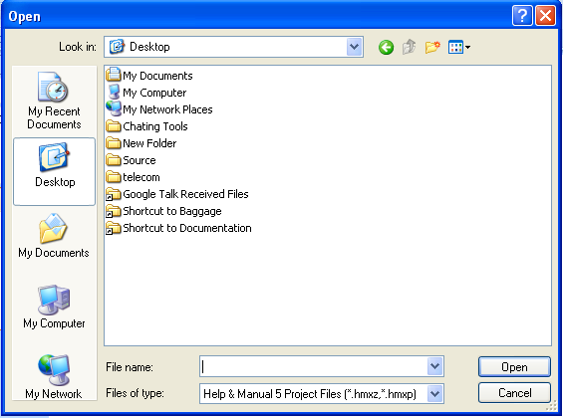
- Open folder
- Select the Project, click on Open the project displays on the skin.

Configuration:
On the Configuration Three Project Properties group are there
- Common Properties,
- HTML Page Templates
- Publishing options
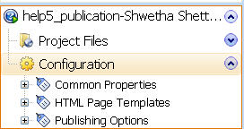
Figure 10: Configuration Properties
- Three Project Properties
- Make changes such as color, logo on the skin project
- On the left navigation bar the configuration section includes many options
- One is the basic and the other is a HTML code view which is the advanced one
- So some of the features may not be available in the basic view but you can code them in the HTML view
- Required Microsoft FrontPage
- Add the logo top, left and right and then add the logo in the top pane
- Use icons for the Top , Next and Previous hyperlinks

Microsoft FrontPage:
Microsoft FrontPage is an easy to use Windows WYSIWYG HTML editor. FrontPage is a text and WYSIWYG Web page editor for: Windows.
- It allows creating whatever you want in the design view
- It automatically generates the HTML code
- It always helps if you know basic HTML syntax
- Can copy the HTML code from FrontPage into the tool's html view
- The same effect in your online help output
The below screen shot displays about FrontPage
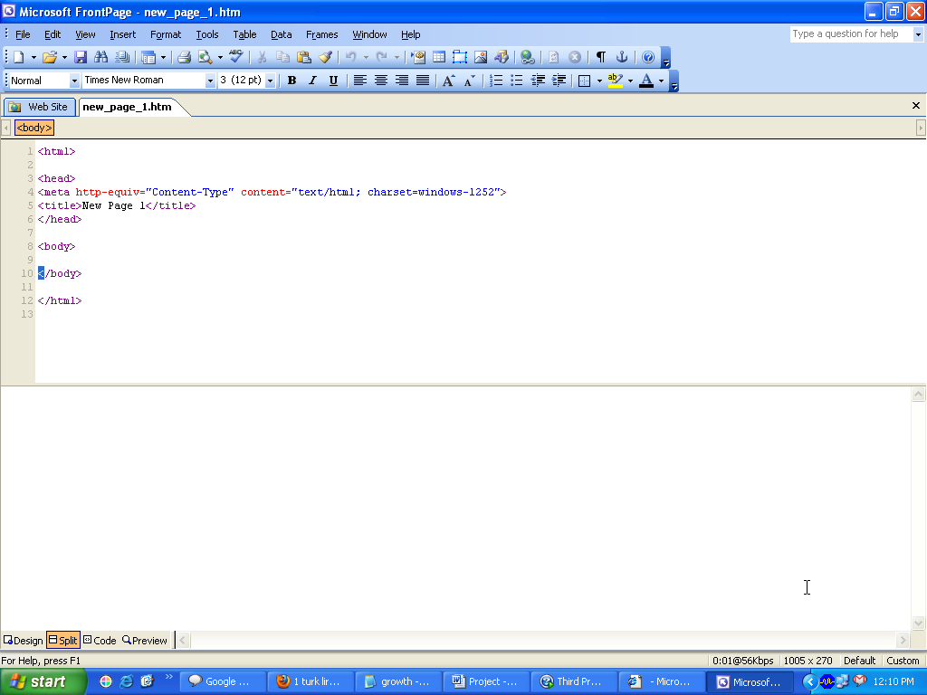
Figure 11: FrontPage

Common Properties
This section contains properties that are shared among all output formats of Help and Manual under these, two Predefined variables are there
- Text Variables
This section allows you to define and store any number of variables for use in your project. This is very useful for texts that may change after you create your project. You can then change the texts in your entire project just by editing the variables, and you are always sure that all instances have been changed.
The below screen shots displays the changes made to the text variables:
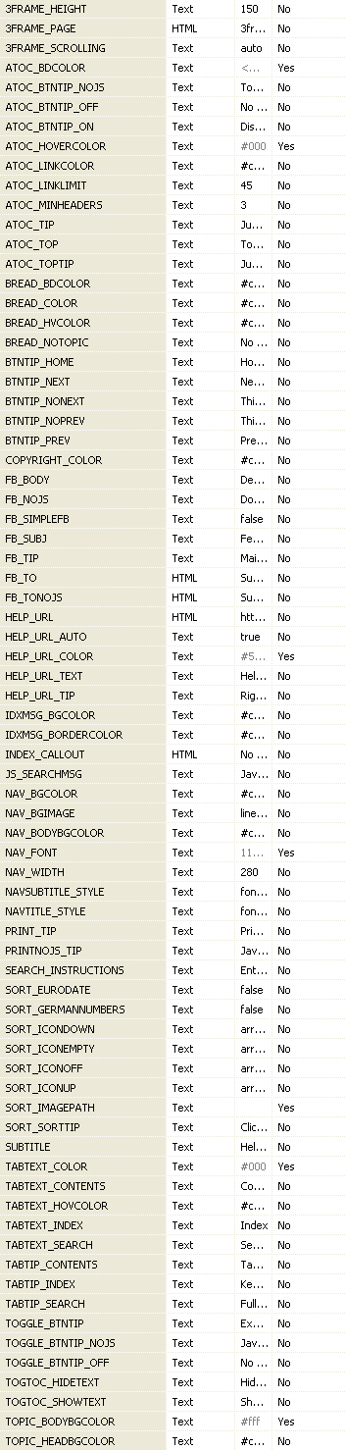
Figure 12: Text Variables
To change the color of Left Navigation Bar
- Go to Common properties from the Configuration section
- Select Text Variables
- Click on the pre-defined variables section as displayed in the below screen:
- Change the color code
- Save
- Generate the Webhelp

To change the color of Content, Index, Search
- Go to Common properties from the Configuration section
- Select Text Variables
- Click on the pre-defined variables section as displayed in the below
- Change the color code
- Save
- Generate the Webhelp

To change the color of the Next, Previous, Print, Atoc Tab
- Go to Microsoft Office Picture Manger
- Click Edit Pictures
- On the right side you get an option: “Edit Using These Tools”
- Select Color: Hue and saturation settings As given below
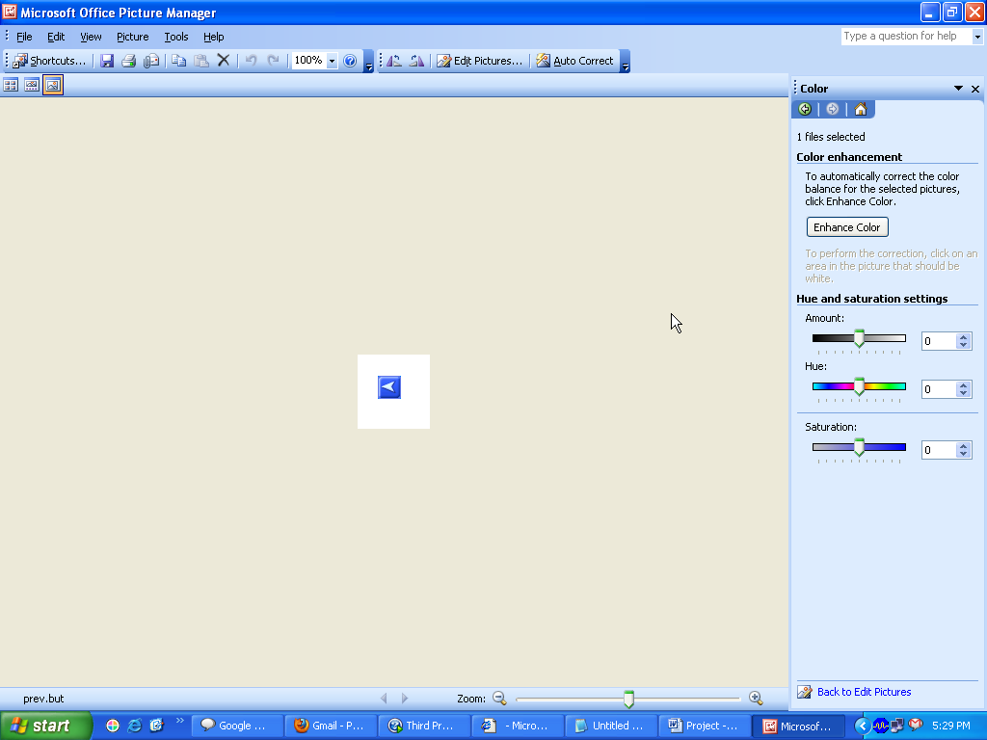
NOTE:
The following variable names are pre-defined like “TITLE, COPYRIGHT, CITATION, SELF, DATE, DATELONG, TIME, TIMELONG, NOW, TOPICLASTEDITED, MONTHNAME, YEAR and several more

Custom Build:
This section allows you to define your own include options, which are also referred to as build options. These options s are like tags that you use to include or exclude text, topics, chapters or entire modules from your help output. You simply tag content with your include options in your project and then select or deselect the corresponding options in the Publish dialog when you compile.
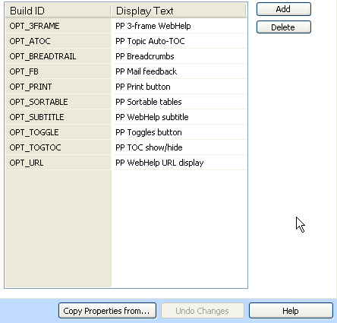
Figure 13: Custom Build
NOTE:
The following build names are reserved and cannot be used: ALL, CHM, HLP, HXS, HTML, PDF, PRINT and EBOOK.

HTML Page Templates:
The HTML topic page templates are used to define the layout and behavior of topic pages in all HTML-based output formats (HTML Help, Webhelp, Windows Exe and ePub
E-Books and Visual Studio Help / MS Help). By default there is just one template called Default which is assigned to new topics automatically. However, you can define as many different templates as you like.
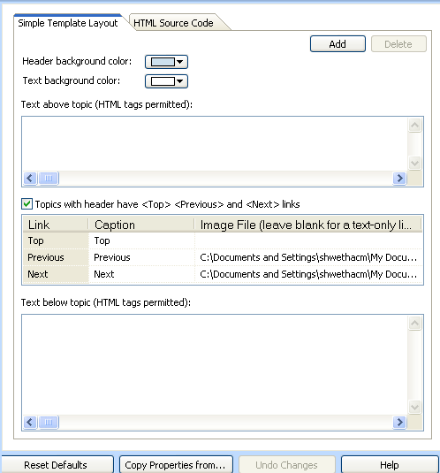
Figure 14: HTML Page Templates

Background colors:
These settings set the background colors for your topic header and body. The colors will be shown in the Help & Manual editor.
Text above topic:
Everything you enter in this box is inserted at the top of every topic, before your topic text. Effectively, this adds a header to your topics (beneath the actual topic header containing the topic title). This text is only shown in your output, not in the Help & Manual editor.
You can enter HTML tags here to format the text, including references to images.
Topics with headers have <Top>, <Previous> and <Next> links:
This allows you to activate navigation links in your topic headers, either as simple text links or is a graphical icon. To insert an icon click in the Image File column, click on the Browse button and select the file.
Image files must be located in one of the folders listed in your Project Search Path settings in Configuration -> Common Properties -> Project Search Path.
Text below topic:
Everything you enter in this box is inserted at the bottom of every topic, after your topic text. Effectively, this adds footer to your topics. This text is only shown in your output, not in the Help & Manual editor/skin.
Here too, you can enter HTML tags here to format the text, including references to images.

Publishing Options:
Once you have made all your preparations and set your configuration options for the output format you are using compiling is basically just a question of selecting Publish and choosing the output format.
- Save your project, then select Publish in the Project tab. clicking the top half of the Publish button or selecting Publish with Options displays the Publish dialog:
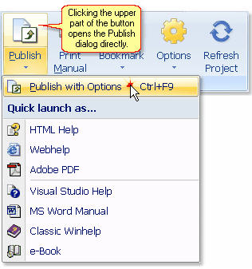
Figure 15: Publish Options
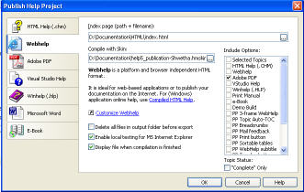
Figure 16: Publish Help Project
Note:
The Quick Launch options publish your project to the selected format directly, without displaying the Publish dialog. This uses
- Select the output format from the list on the left. Some of the options displayed in the dialog will change depending on the format you choose
- Check the Output File: field. In most cases the program will automatically publish to the project folder, using the project name as the file name. You can change both the output folder and the file name if you want and Help & Manual will remember this change next time you publish.
- Select the output options and click on OK to publish. This can take a couple of minutes with very large projects.

Webhelp:
Webhelp is uncompelled HTML.Use this output format to create online help for Web
Applications or simply to publish your help file on the Internet. Webhelp is platform and browser independent .It runs on Windows, Linux, Apple and other operating systems. All that is required to view this help format is a HTML browser, optionally with JavaScript enabled.

The Layout Section
The options in this section control the layout of your Webhelp.
No Frames, No Scripts: This option is only for users who want to manage all their help topic files themselves. It does not create an integrated help system. The TOC file and all the topic files are separate HTML files.
Two Frames: This is the default. It creates a standard help system with the same layout and navigation as HTML Help.
Three Frames: It adds a top frame in which you can insert the header of your website or any other web page. When you choose a 3-frame layout you can either load an existing page into the top frame or edit the code for the top frame directly in the Layout section.
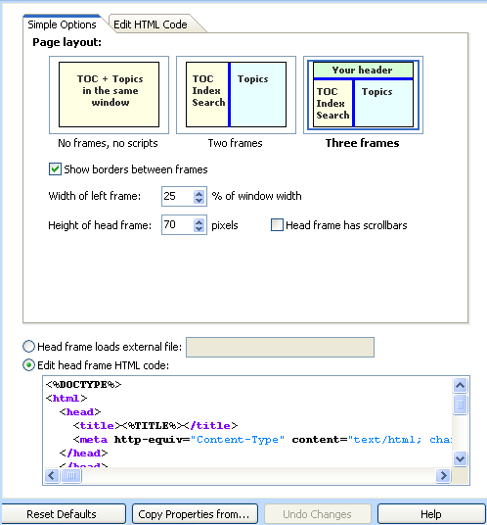
Figure 17: Layout Section

To get Company Logo and header background color:
Save the Company logo on the folder and type HTML tag manually on the layout section where it mentioned: “Edit head frame HTML code” section to get the Company Logo at the Top header and the background color.
Type manually the HTML source:
<body bgcolor="#1857a7"><img src="SM.jpg"align="right" >
As below:
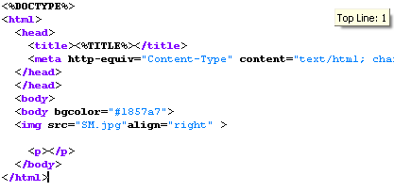

The Navigation Section:
This section controls how Help & Manual generates the navigation for your Webhelp. Most of the options should be self-explanatory. For full details see Navigation in the Project Configuration chapter.
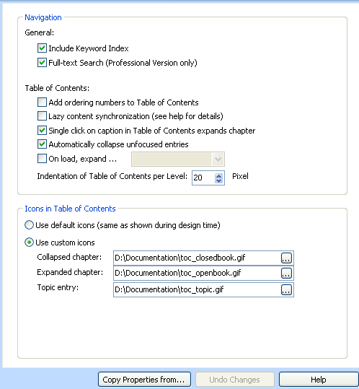
Figure 18: Navigation Section

The Table of Contents, Keyword Index and Full Text Search Section:
These sections configure the Contents, Index and Search tabs of your Webhelp output. In addition to this you can also edit the HTML templates that are used for generating these tabs. Editing HTML templates directly requires experience with editing HTML code. If you are just getting started with Help & Manual it is recommended that you only use the default settings in the Simple Template Layout tab.
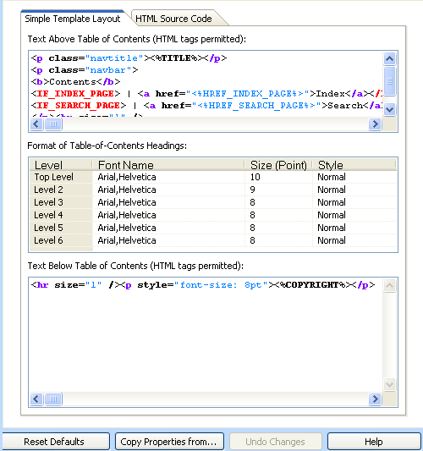
Figure 19: Table of Contents
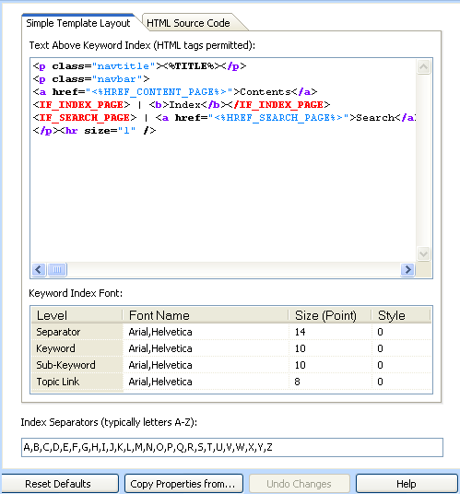
Figure 20: Keyword Index
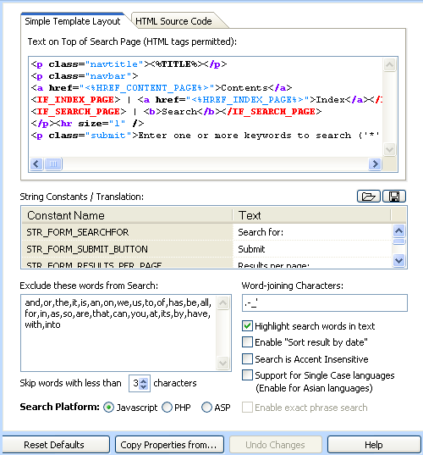
Figure 21: Full Text Search
Note:
We can make required changes on the Webhelp sections

Project Files

Baggage Files:
This topic summarizes how Baggage files are handled by Help & Manual. This information will help you to understand how Baggage works.
- Graphics in the Baggage section can be used for all output formats. If you use graphics formats not directly supported by the output format they will be converted automatically when you compile, just like the other graphics in your project.
- Non-graphics files in the Baggage section are only relevant for HTML-based formats. They are ignored in all other formats.
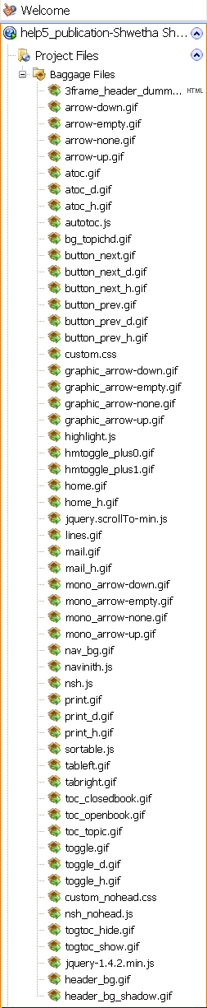
Figure 22: Baggage Files

Importing Baggage files from other projects
You can import all the Baggage files from another Help & Manual project to the current project. Files with duplicate names will be overwritten when you do this.
- Select the Baggage Files section in the Project Explorer
- Right Click on Baggage File -> Add New File -> the below screen displays
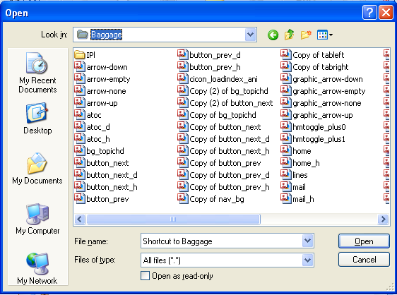
Figure 23: Importing Baggage File
- Select the Help & Manual and import the Baggage files from the folder.
- You will be asked if you want to import the Baggage files from the selected
- Click on Open.

Removing Baggage files
- Go to Project Files > Baggage Files in the Project Explorer
- Select the Baggage file you want to remove. Press DELETE or select Add File > Delete Entry in Project > Manage Topics.
Note:
This physically deletes the selected file from your project. If you want to keep a copy of it exports it first before deleting it (see below).

Renaming Baggage files
You cannot rename Baggage files directly in Help & Manual. To rename a Baggage file remove it from the Baggage list (see above), rename the original file and then add it to the Baggage list again.
Warning:
Do not attempt to rename Baggage files on the disk in Windows Explorer; doing this will cause errors in your project!

Why to Use Help and Manual?
Create hyperlinks by dragging and dropping. Add graphics and multimedia elements in seconds. Make screenshots of your application with the integrated screenshot tool and enhance them quickly with the screenshot editing program. Compile your project to any supported output format with a couple of clicks. Work in collaboration with a team of authors all editing the same project at the same time. Produce help and documentation faster and more efficiently and have fun in the process!
- Save Time
- Save Money
- Concentrate on your work
- Work in Team
- All standard help formats are supported
- Reuse Content
- Localize your documentation
- Supply a User Manual.

Final Output of the PROJECT SKIN
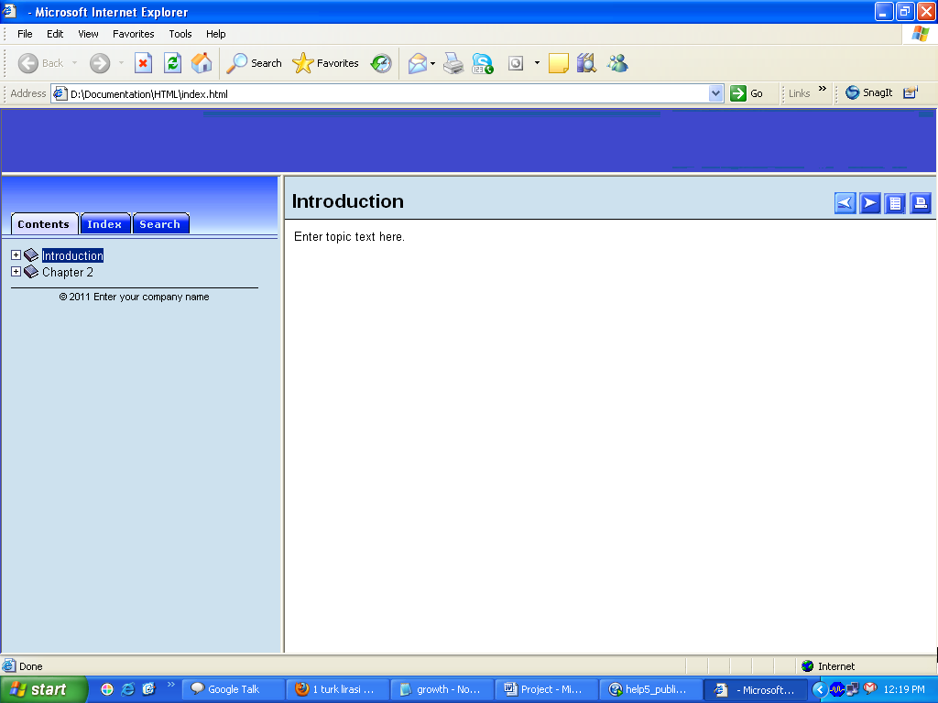
Figure 24: Project Output

*******************************End of the Document*************************

